Submission to APS Review

Introduction
Dear APS Review Panel, thanks you for providing the opportunity for public servants at all levels to provide you with input on the review. The APS plays such a critical role not only as policy adviser to Government but also as a collaborator, service delivery mechanism and as connective tissue between institutions in industry, state, territory and local governments and in the third sector. It is so important that we are in a position to optimize our public system.
I am in a small cohort of people who have a very wide breadth of experience across eight Commonwealth agencies including central agencies, policy, several regulators and law enforcement/national security. I bring to you my observations from this breadth of cross organizational experience.
I also should apologise, due to the timeframes for submissions I have not had the time to run an editorial eye over this piece, so much of it has been written as a flow of consciousness.

Unifying Purpose and Vision of the APS
In human systems of organization, a shared sense of direction and purpose is critical to provide the organizing logic that determines the allocation and prioritization of resources, the framing for strategic risks, the alignment of individual business activities towards greater objectives and the sense of commitment.
At a whole of APS level there is a noticeable absence of such a unifying purpose, expect in a limited way within the Public Service Act (s10). The purpose has therefore been devolved to the agencies to determine individually (as set out in the Public Governance Performance and Accountability) Act.
While it may not be immediately evident, it is my view that the lack of unifying purpose plays a significant role in the weaknesses the APS has in collaboration and coordination, governance, strategic decision-making and organizational performance management.
At a macro strategic level such a purpose statement should focus on delivering economic, social, security and environmental benefits by designing and implementing regulation of economic activity.
Proxy purpose statements that are often used are “to serve the government of the day” or “to provide apolitical advice to the government of the day”. However, in my view neither of these give satisfactory coverage to a broad range of institutions that have express statutory independence from the “government of the day”, but nonetheless exist to deliver results to a broader public good. Most if not all Regulators would fall within this category.
To make this a little less abstract, I did some work with AUSTRAC (Australia’s Money Laundering and Counter-terrorism financing (AML/CTF) intelligence agency and regulator) on their organizational strategy and risk management framework. Originally AUSTRAC had articulated its purpose as “detection and disruption of money laundering”. I asked “why”, “why do we expend Government resources on this?”. The answer is of course that money laundering and terrorism financing create economic and social harm to Australia and this should in turn be included in the purpose of the Agency.
In my view this logic is applicable to all Government agencies, it is merely the source of the economic and social risk that changes, e.g. in a Home Affairs context it is the economic, social and security harms that flow from excess to economic demand and/or illegitimate persons and products entering the country.
For a Central Agency like PM&C it is (roughly) the economic and social harm that flows from poor, decision-making, poor policy solutions and poor coordination across government. The usefulness of lifting it the this level is that we can start asking ourselves honest questions about how well we are managing these harms, and are our limited resources tuned to manage where the risk is greatest and therefore contribute to the greatest economic and social improvement.

Performance in economic and social terms
To continue the argument above then, one of the big gaps that I have observed across the APS is a failure to be able to articulate the economic and social benefit of policy solutions except sometimes in the most rudimentary terms, and therefore there is generally a focus in planning and performance on measuring an agencies outputs rather than the impact it has on Australian society.
One of the main reasons is because it can be very hard to measure – however in my view there is a huge false economy in this space insofar as investment in government interventions that do not work can continue unabated for years.
I also think that the difficulty in measurement is fast becoming a poor excuse for laziness, in an era where our ability to collect and manipulate data from across the economy and society has never been greater and in fact we can expect in the future our ability to use data to exponentially increase. As a service, our time to change the way we look at organizational performance is now, so that we can capitalize on these opportunities as soon as possible.
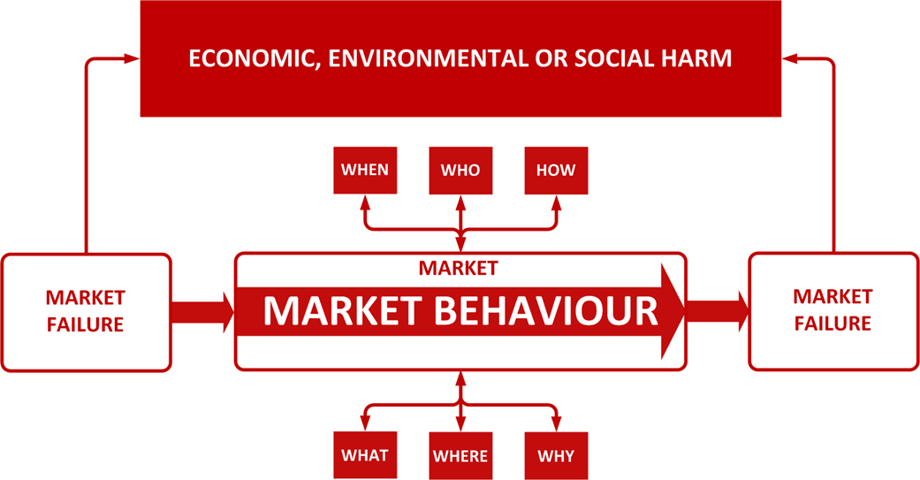
Again (and apologies) to use an example of work I have been pursuing with AUSTRAC and in collaboration with the ANU to improve its ability to measure and improve performance, we have started work on a Money Laundering and Terrorism Financing (ML/TF) Economic and Social Harm Index and a cost benefit/tool.
The purpose of this is to develop an index and measurement of the harms that different ML/TF typologies create on different sectors of the economy, so that AUSTRAC can direct its resources to the criminal activities that matter the most, measure its capability to prevent and detect different forms of ML/TF and make improvements that contribute back to the economy.
This work will be difficult and there significant challenges to develop and structure the data, however if a small agency like AUSTRAC can take this on there can be no excuse that other agencies do not make the effort to get line of sight to the economic and social benefit they are there to deliver to Australians.
A related issue, which I will discuss below is ensuring that the APS has the data literacy to both create these kinds of indices and to interpret the performance information which flows back from them.

Evaluation
A further component of organizational performance that seems to have fallen into disrepair is the evaluation capability of agencies (with a few exceptions). The lack of capability in the area seriously undermine sour ability as a service to demonstrate to ourselves and to the public that our interventions are effective. In the context of the growing speed of our economy and global connectivity, I can’t see how we can afford to live without the capability to ensure our interventions are fit for purpose and continuously tuned to the contemporary environment.
Evaluation also plays a hugely under-recognised role in the development and refinement of policy interventions. All too often we see policy interventions which are not fit for purpose being developed and never given a logical evaluation or similarly problematically policy interventions which may need tweaking are discarded entirely because the effort is never put into understanding what aspects of a program are not operating optimally, throwing the baby out with the bath water.
There has been debate over the years about the stewardship of evaluation capability in the Commonwealth. It currently resides with the Department of Finance as part of the ongoing stewardship of the PGPA Act implementation.
However, I think it would be fair to say the Finance has not had the capability in this space since evaluation capability was decommissioned in around 1996-1997, and it has not been able to recover this.
Later discussions have suggested that a statutory Evaluator-General should provide the stewardship in this space, both as a standard setter for internal evaluation and the conductor of major evaluation activities for complex and high value areas of public policy intervention, in the same way as the Auditor-General. I think this model has merit that is worth considering.
Whatever the model, it is clear that evaluation needs to make a comeback in Government if we are to keep creating and maintaining effective programmes. I also think that it is clear that the articulation of evaluation and its role needs to be very clear in legislation. The current phraseology in the PGPA Act is too subtle and does not seem to be effecting the right investment in evaluation, and performance continues to be viewed as primarily a compliance exercise to be acquitted through annual reports.

Improving the Cabinet Products - Investment Logic Mapping - Data for Decision
The Cabinet provides the highest level of governance oversight and is the key body for investment decisions in the Commonwealth. A substantial amount of research has been undertaken in relation to decision-making in the private sector, including better understanding decision biases, how to present strategic information and data, understanding complexity and risk in decision-making, how good assurance practices work to test information. I have not seen the same level of thinking and analysis in the public sector.
The Cabinet therefore currently relies on long-convoluted narratives to make decisions, rather than structured logic, there do not appear to be clear assurance functions (with the exception of cost and revenue assurance) and the Cabinet is not often provided with options for decision. In my view this plays a fundamental role in the quality of policy decision-making and implementation.
The Victorian Government has implemented Investment Logic Mapping for its investment decision-making. This approach provides a clear relationship between the inputs-outputs-outcomes of a policy intervention and thereby improves the ability of the Cabinet to make decisions, but also can provide a clearer structure for assurance on each component of this logic, by a relevant assurance steward for the Government (e.g. Finance for Financial inputs, APS Commission for human resource inputs, implementation bodies and other stakeholders for the outputs and outcomes).
In my view there is a substantial opportunity for the Commonwealth to adopt this mature approach to decision logic. Additionally, this kind of articulated logic betters support the evaluation of programs as set out above, because the intent and structure of a program becomes much clearer and the data requirements for evaluation can be equally more clearly defined.
Finally, with the recent establishment of the Data Commissioner, I think there is further opportunity to consider how to provide more data enabled decision-making to the Cabinet, including through modelling of different policy scenarios, big data analysis on implementation activities and policy interventions across government and provision of modern decision dashboards for Ministers and the Prime Minister.
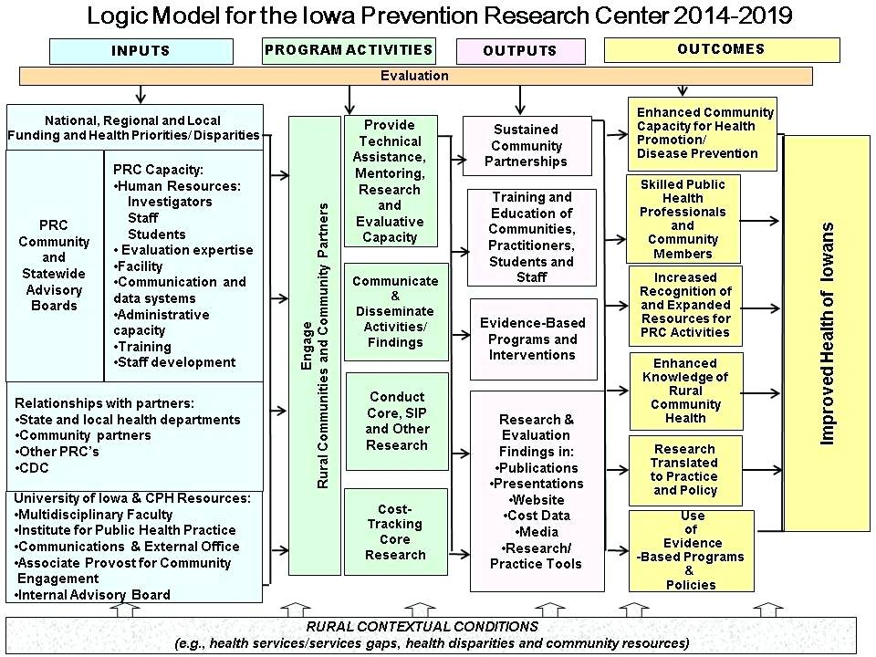
Financial Management
Similarly, there is significant opportunity for the Commonwealth to mature its approach to financial management. The current approach is based upon an annual cycle, with an entirely input-based accounting framework, which therefore does not give the government any sense of what is being delivered for an allocation of funding. It also means that Budgets are created in a “set and forget” way meaning that policy and program investments are not made with either a view of current investment or competing investment (as well as above – without a view of the economic and social return for competing investments).
In my view there is opportunity to consider implementing rolling budgets, where government is given the opportunity to consider its investment portfolio more holistically and to make prioritization decisions based upon the outputs and outcomes that it is investing in.

Centralisation vs Standardisation
In my view, the movement towards a decentralized model of public service has had some merit, but as these things usually go, the decentralization has had a major impact on consistency across government in terms of services, investment approaches, data standards, stakeholder relationships…etc. To counteract the impacts of these, we do not need to swing back towards a more centralized model of Government, but we should consider how to effect more standardization of government business architecture.
There are several strong examples of how this has resulted in major uplift in effectiveness in both the Public and Private sectors.
The Australian Taxation Office, undertook work to develop business patterns for taxation across its various lines of taxation, to standardize business process, data models, products…etc. This has resulted in an ability for the ATO to implement new taxation arrangements more quickly, to reduce implementation costs and to promote some consistency of service. Given the positive impact, the ATO also worked with Treasury to feed these patterns into the drafting of new legislation so that there would be consistency right up in the policy design space.
BHP designed standard patterns for mines, which included parameters which could be changed for local conditions (e.g. the depth of ore, the terrain…etc.). as above this enabled faster implementation time, but also the modelling enabled better upfront investment decision making
McDonald’s, the most successful restaurant chain in the world, has standardized its operations across an internationally distributed franchise based business model, which provides for standards of efficiency, enables new products to be integrated quickly and importantly provides a consistent and predictable experience for customers anywhere in the world.
The Australian Public Service is essentially a distributed and differentiated business model, which delivers essentially the same services in different forms across different markets, risk-based regulation, grants and contract management, market based regulation, payments services, revenue collection . Each of the above examples I think highlights potential opportunities to develop a greater standardization to achieve better customer experience, faster “speed to market” and greater efficiency.
The above models have also demonstrated a need for design governance at a government level. Each organization has taken a different approach to managing this governance and if the APS aimed towards greater standardization there would need to be further consideration of the best governance model.

Breaking the Policy versus Implementation Dichotomy
There continues to be a narrative across government which separates “policy” from “programs” and “implementation”. Having worked across so many different agencies I have seen firsthand the harmfulness of this false dichotomy. It is built right into the structures of our organisations and unnaturally separates different skill types across a continuum of design and development for government intervention. Essentially it creates multiple handover points where an intervention is effectively “thrown over the fence” to the next set of persons in line, usually ending up at a regulatory entity that has to make sense of a regulatory framework which has not necessarily had recourse to the real on the ground issues or where the greatest public benefit can be generated.
In my view the structure needs to be broken, and the excess value ascribed to policy development needs to be addressed before we can address this situation. Firstly, there is a developing evidence that iterative interventions designed by multi-disciplinary teams including policy, implementers, communications specialists, evaluators…etc, are more effective than the traditional practices of handovers across starkly defined lines of accountability.
The Department of Immigration (now Home Affairs) is an example where the policy making, service delivery, law enforcement, regulation functions have all been brought together. In my view there were some major advantages to this, for example (not exhaustive) – data from interventions ws immediately available to policy makers, Policy makers could discuss changes readily with the regulatory enforcers, law enforcement could liaise with peers in broader law enforcement and bring back results directly to performance evaluators…etc. For a very complex organization this enabled Immigration to progress work more quickly than many other organisations (don’t get me wrong though this was a long way from perfect).

Promoting Collaboration
The Public Governance Performance and Accountability Act is structured around the concept of an “Accountable Authority”. This inherently has created vertical accountability right to the top of the service, without any horizontal accountabilities for collaboration or alignment. This is further increased by accountabilities to the Minister. In fact from a systemic and structural perspective, it would appear that the first point of collaboration is at the Cabinet level, although at this point it is too late is policy has been created without a collaborative approach beforehand.
This is not to say that collaboration does not occur, but it is not institutionalised and does not have the right process and decision-making tools to promote shared or collaborative design and implementation of policy. It is my view that we would do well to seek institutional responses to promote collaboration, through revisions to the legislation to promote collaboration, a clearer role for Secretaries Board, an emphasis on joint submissions coming forward for cabinet consideration, forums to discuss and govern the design of the APS in an ongoing way and more open and less hindered communication channels for officer level discussion across the Commonwealth.

Innovation and Research System
Innovation is a term that is throw around freely in the Commonwealth, but it seems to me that there isn’t a great understanding that Innovation doesn’t arise through magic but actually needs to be an integrated investment process which promotes ideas, filters them, tests them and aligns them to overall investment priorities. If we are serious about innovation in Government, then we should consider having research and innovations functions either in each Department or centrally managed with a channel to government level investment processes.
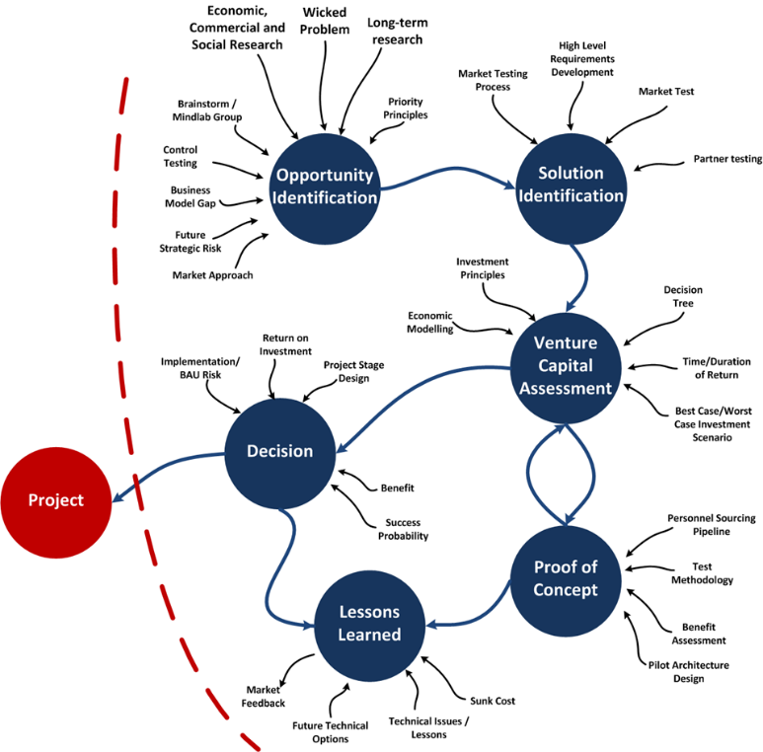
We should also consider more institutionalized relationships with research institutions including the universities – attempts were made to do this but were stymied by diminishing investment following the Global Financial Crisis. I think we would benefit from looking at how Research and Development is done in major firms to develop the right investment and staging practices in Government. (The above diagram is an investment framework my team and I developed while I was A/g Assistant Secretary for Innovation in Immigration – and shows broadly how the process of investment worked and was integrated to broader investment.)

Senior Executive Development
With respect, I think many of the issues above also stem from a lapse in capability development for APS leaders, which has been under-emphasised and under-invested in for some time in my view. In my view there needs to be a far greater focus put on developing SES in terms of leadership capability, using the wealth of research and literature on the topic which has been developed over the past decade or so. To understand the absolutely substantial impact that leadership plays in organizational effectiveness, Maj Gen John Cantwell , in his book Leadership in Action has dedicated an entire chapter to explaining the productivity, engagement, commitment, adaptability, collaboration benefits that good leadership provide to an organization, and on the flip-side the major negative impacts of bad leadership. Given these, I think it is critical that we make a more structured investment in developing leadership capability within the SES and through career.
The second important facet in my view is the development of business acumen needed to be an organizational steward and manager in the SES. Many of the issues above stem in my view from inadequate an non-integrated knowledge of organizational management, financial management, business design, economic analysis, evaluation, business process optimization and strategic risk management. These are all important core knowledge for senior leaders which should not be underestimated. The equivalent of this body of knowledge in a private sector context is the Master of Business Administration (MBA), but we do not have an equivalent body of knowledge which is well integrated in the public sector context.

Merit Based Recruitment
In a related issue, the APS strongly in theory emphasizes merit-based recruitment, particularly for SES recruitment. In practice, senior managers are not shy about letting people know that often your “sponsors” play a greater role in the recruitment process that genuine merit. I think our approach to merit in senior recruitment needs to be re-examined. One of the major impacts of the current approach is that it substantially reduces the diversity of the SES cohort and it actively operates as a disincentive for movement across public sector organisations as you often lose your sponsors. Diversity of experience and diversity of thought process are too often devalued in this process. Given the fact that 75% of the APS have only worked in one agency, I think the diversity of experience across the service and across different role types needs to be more greatly supported, proactively nurtured and given some emphasis in recruitment processes, especially for central agencies.

Thank you again for the opportunity to contribute to the review of the APS. I apologise again for the narrative structure of this input, but I hope nonetheless that the key ideas of this input can usefully contribute to the future development of the APS.

Regards,

Current Public Servant.

